Structure Research - TMS

Date:
6/14/2025

Researcher(s):
Scott Cripps

Objective of research:
To explore materials and methods used in underwater ROV frames and housings, laying the groundwork for trade studies.

Notes:

HDPE
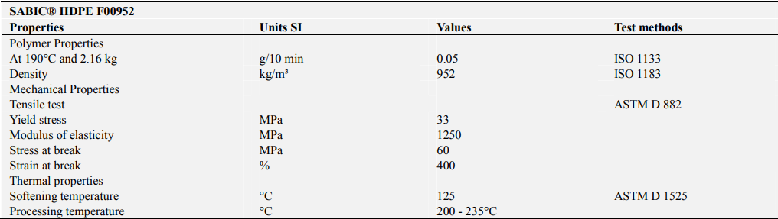

PVC

Aluminum

Acrylic

Sources:
Mechanical and Physical Properties of PP and HDPE doi: 10.11648/j.es.20190402.12 PVC Properties and Applications: htps://doi.org/10.1007/s10853-024-10471-4
Aluminum Properties and Applications: https://doi.org/10.18485/aeletters.2018.3.2.2
Acrylic Properties and Applications: DOI: 10.9790/1684-1302010104

